IT Infrastructure

Network Team: -
- Youssef Mohamed Hussein 2023/03820
- Malak Mostafa Zaki 2023/04840
- Dana Sameh Mohamed 2023/08899
- Jomana Yasser Mohamed Aly 2023/04423
Servers Team: -
- Aida Bahaa Abdelmesieh 2023/06836
- Saja Hany 2023/05663
- Malak Akram 2023/00997
- Mennatallah Osama 2023/06241
Penetration Test
- Ayah Ahmed Yousef 2023/05340
- Shahd Mahmoud Hassanein 2023/02021
Ethical hacking
- Youssef Ahmed Salah 2023/07736
- Ahmed Mohamed Ahmed 2023/04661
- Adam Ehab Mamdouh 2023/01176
- Abanoub Atef 2023/10131
- Ahmed Mohamed Sobhi 2023/01261
- Salma Yasser 2023/00364

Contents
Network Planning and Addressing Design 3
Core Switch (Cisco 3560 catalyst) 4
Step 1: Enter Configuration Mode & Set Hostname: - 4
Step 2: Configure DHCP Excluded Addresses: - 4
Step 3: Configure DHCP for Wired Users (VLAN 10): - 4
Step 4: Configure DHCP for Wireless Users (VLAN 20): - 4
Step 5: Configure VLAN Interfaces (SVI): - 5
Step 6: Create VLANs: - 5
Step 7: Configure Trunk Link to Access Switch: - 5
Step 8: Configure EtherChannel: - 6
Step 9: Configure Port-Channel: - 6
Step 10: Configure ACL for Server Security: - 6
Step 11: Apply ACL to VLAN 30: - 6
Step 12: Configure Spanning Tree: - 6
Step 13: Verification Commands: - 7
Access Switch Configuration (Juniper EX3200) 10
Step 1: Enter Configuration Mode: - 10
Step 2: Create VLANs: - 10
Step 3: Configure Wired Client Ports (VLAN 10): - 10
Step 4: Configure Access Point (Wireless VLAN 20): - 10
Step 5: Configure Trunk Link to Core Switch: - 10
Step 6: Configure Spanning Tree: - 10
Step 7: Configure DHCP Relay: - 11
Step 8: Apply Configuration: - 11
Server Switch Configuration (Cisco Catalyst 3560) 15
Step 1: Hostname Configuration: - 15
Step 2: VLAN Creation: - 15
Step 3: Port Assignment: - 15
Step 4: Trunk Configuration: - 16
Step 5: EtherChannel Configuration: - 16
Step 6: Spanning Tree Protocol (STP): - 16
Step 7: Save Configuration: - 16
Step 8: Verification: - 16

Network Planning and Addressing Design

Network address: - 172.16.0.0/24
IPV4 32 bits 32-24 = 8 host for network
- 11111111. 11111111. 11111111. 00000000 = 255.255.255.0

VLANs
Wired users | Wired users | Servers
VLAN 10 | VLAN 20 | VLAN 30

According to this, we have 3 VLANs so we need 3 subnets
Subnet = 2^n 2^2 =4 subnets so, we need 2 bits
Number of usable hosts per subnet = 2^h-2
h number of hosts = 2^6 - 2 = 64 – 2 = 62 host

Network address: - 172.16.0.0/26
- 255.255.255.11000000 255.255.255.192
 | Network | First usable | Last Usable | Broadcast | Gateway
VLAN 10 | 172.16.0.0/26 | 172.16.0.1 | 172.16.0.62 | 172.16.0.63 | 172.16.0.1
VLAN 20 | 172.16.0.64/26 | 172.16.0.65 | 172.16.0.126 | 172.16.0.127 | 172.16.0.65
VLAN 30 | 172.16.0.128/26 | 172.16.0.129 | 172.16.0.190 | 172.16.0.191 | 172.16.0.129

Core Switch (Cisco 3560 catalyst)

Step 1: Enter Configuration Mode & Set Hostname: -
- enable
- configure terminal
- hostname CORE-SW
We access privileged mode and configure the switch name for identification in the network.

Step 2: Configure DHCP Excluded Addresses: -
- ip dhcp excluded-address 172.16.0.1 172.16.0.9
- ip dhcp excluded-address 172.16.0.65 172.16.0.69
- ip dhcp excluded-address 172.16.0.129 172.16.0.139
These IPs are reserved for gateways and servers and will not be assigned dynamically to clients.

Step 3: Configure DHCP for Wired Users (VLAN 10): -
- ip dhcp pool wired_users
- network 172.16.0.0 255.255.255.192
- default-router 172.16.0.1
- dns-server 8.8.8.8
- exit
This creates a DHCP pool for wired users and assigns IP addresses automatically.

Step 4: Configure DHCP for Wireless Users (VLAN 20): -
- ip dhcp pool wireless_users
- network 172.16.0.64 255.255.255.192
- default-router 172.16.0.65
- dns-server 8.8.8.8
- exit
This pool provides IP addresses for wireless clients connected through the access point.

Step 5: Configure VLAN Interfaces (SVI): -
- interface vlan 10
- ip address 172.16.0.1 255.255.255.192
- no shutdown
- exit
- interface vlan 20
- ip address 172.16.0.65 255.255.255.192
- no shutdown
- exit
- interface vlan 30
- ip address 172.16.0.129 255.255.255.192
- no shutdown
- exit
These interfaces act as gateways for each VLAN and allow inter-VLAN routing.

Step 6: Create VLANs: -
- vlan 10
- name wired_users
- exit
- vlan 20
- name wireless_users
- exit
- vlan 30
- name servers
- exit
VLANs are created to separate network traffic into logical groups.

Step 7: Configure Trunk Link to Access Switch: -
- interface gigabitEthernet0/1
- description LINK_TO_ACCESS_SWITCH
- switchport trunk encapsulation dot1q
- switchport mode trunk
- switchport trunk allowed vlan 10,20,30
- exit
This port carries multiple VLANs between switches.

Step 8: Configure EtherChannel: -
- interface range gi0/1 - 2
- channel-group 1 mode active
- no shutdown
- exit
Combines multiple physical links into one logical link for redundancy and higher bandwidth.

Step 9: Configure Port-Channel: -
- interface port-channel 1
- switchport trunk encapsulation dot1q
- switchport mode trunk
- switchport trunk allowed vlan 10,20,30
- exit
This is the logical interface created by EtherChannel.

Step 10: Configure ACL for Server Security: -
- ip access-list extended SERVER_SECURITY
- permit tcp 172.16.0.0 0.0.0.127 172.16.0.128 0.0.0.63 eq 80
- permit tcp 172.16.0.0 0.0.0.127 172.16.0.128 0.0.0.63 eq 443
- deny ip 172.16.0.0 0.0.0.127 host 172.16.0.150
- permit ip any any
- exit
Allows users to access web servers but blocks direct access to the database server.

Step 11: Apply ACL to VLAN 30: -
- interface vlan 30
- ip access-group SERVER_SECURITY out
- exit
Applies the security rules to traffic leaving the server VLAN.

Step 12: Configure Spanning Tree: -
- spanning-tree mode rapid-pvst
- spanning-tree vlan 10,20,30 priority 4096
Prevents network loops and makes this switch the root bridge.

Step 13: Verification Commands: -
- show ip interface brief
- show vlan brief
- show interfaces trunk
- show etherchannel summary
- show access-lists
- show spanning-tree vlan 10
Used to verify that all configurations are working correctly.

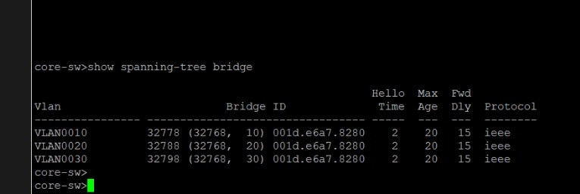
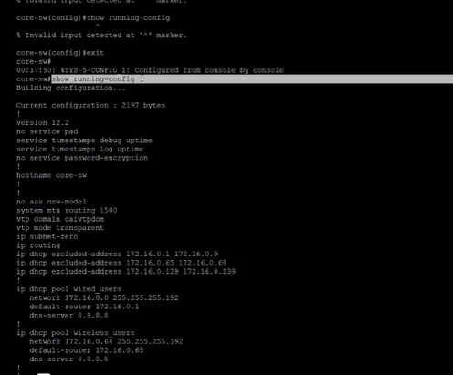

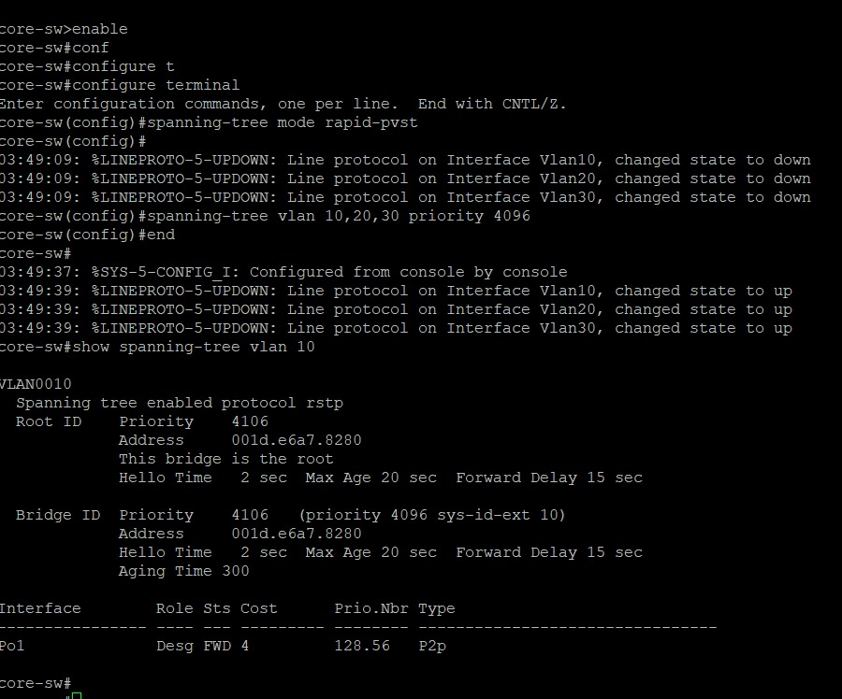
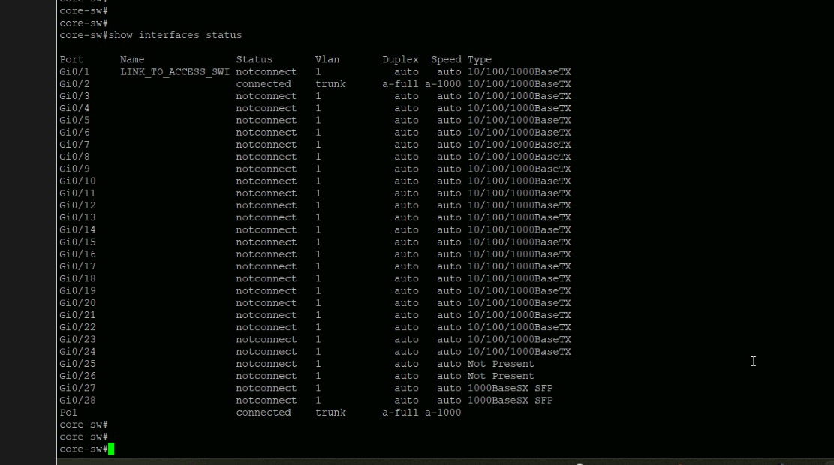
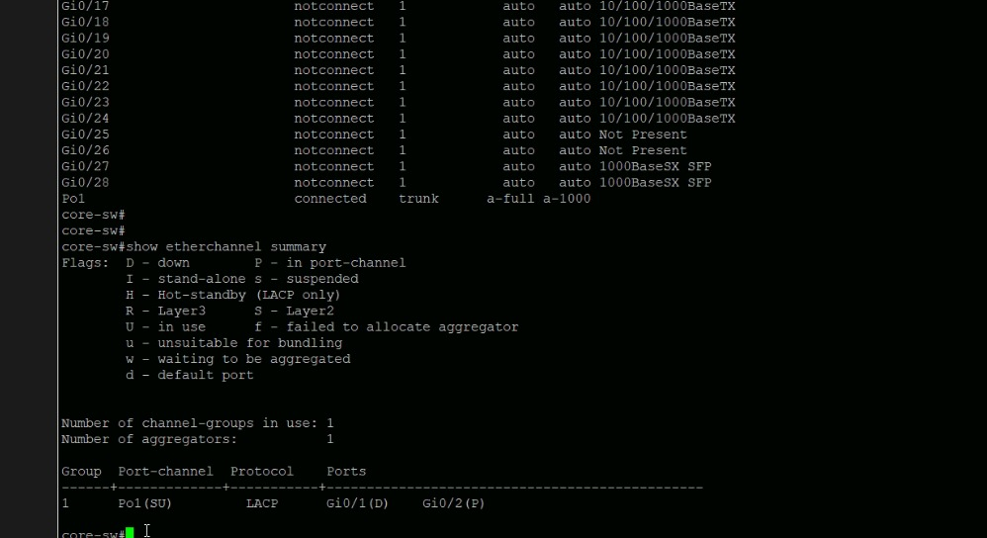

Access Switch Configuration (Juniper EX3200)

Step 1: Enter Configuration Mode: -
- cli
- configure
This command allows us to enter configuration mode to apply settings on the switch.

Step 2: Create VLANs: -
- set vlans WIRED vlan-id 10
- set vlans WIRELESS vlan-id 20
- set vlans SERVERS vlan-id 30
We create VLANs to logically separate wired users, wireless users, and servers.

Step 3: Configure Wired Client Ports (VLAN 10): -
- set interfaces ge-0/0/1 unit 0 family ethernet-switching interface-mode access
- set interfaces ge-0/0/1 unit 0 family ethernet-switching vlan members WIRED
- set interfaces ge-0/0/2 unit 0 family ethernet-switching interface-mode access
- set interfaces ge-0/0/2 unit 0 family ethernet-switching vlan members WIRED
- repeated steps till ge-0/0/8
These ports are configured as access ports and assigned to VLAN 10 for wired users.

Step 4: Configure Access Point (Wireless VLAN 20): -
- set interfaces ge-0/0/9 unit 0 family ethernet-switching interface-mode access
- set interfaces ge-0/0/9 unit 0 family ethernet-switching vlan members WIRELESS
This port connects the access point and assigns it to the wireless VLAN.

Step 5: Configure Trunk Link to Core Switch: -
- set interfaces ge-0/0/24 unit 0 family ethernet-switching interface-mode trunk
- set interfaces ge-0/0/24 unit 0 family ethernet-switching vlan members [ WIRED WIRELESS SERVERS ]
This trunk port carries all VLAN traffic between the access switch and the core switch.

Step 6: Configure Spanning Tree: -
- set protocols rstp interface ge-0/0/1 edge
- set protocols rstp interface ge-0/0/2 edge
- repeated steps till ge-0/0/9
Edge ports are configured for faster connection and to prevent STP delays on end devices.

Step 7: Configure DHCP Relay: -
- set forwarding-options helpers bootp server 172.16.0.1
This forwards DHCP requests from clients to the Core switch where DHCP is configured.

Step 8: Apply Configuration: -
- commit
This command saves and applies all configuration changes.

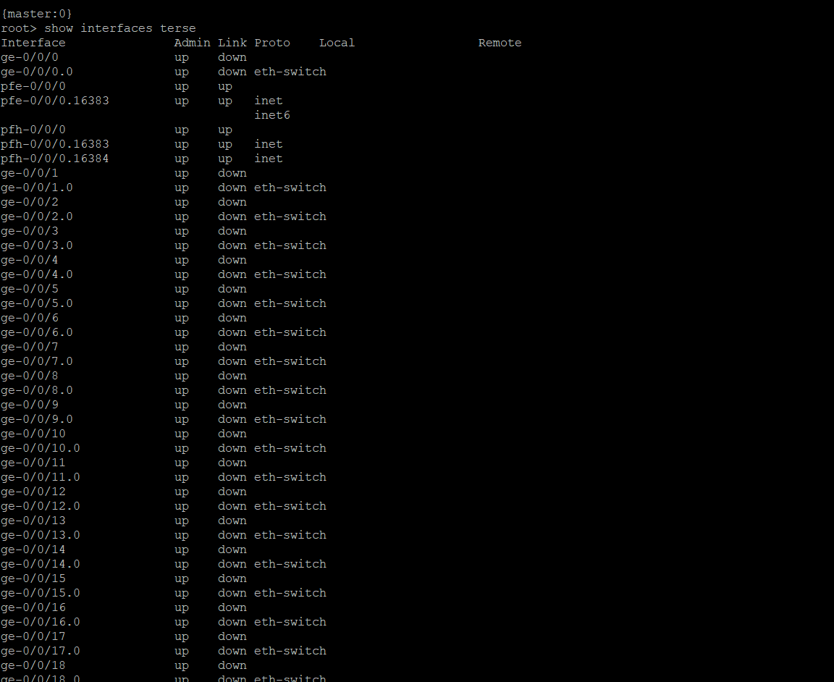
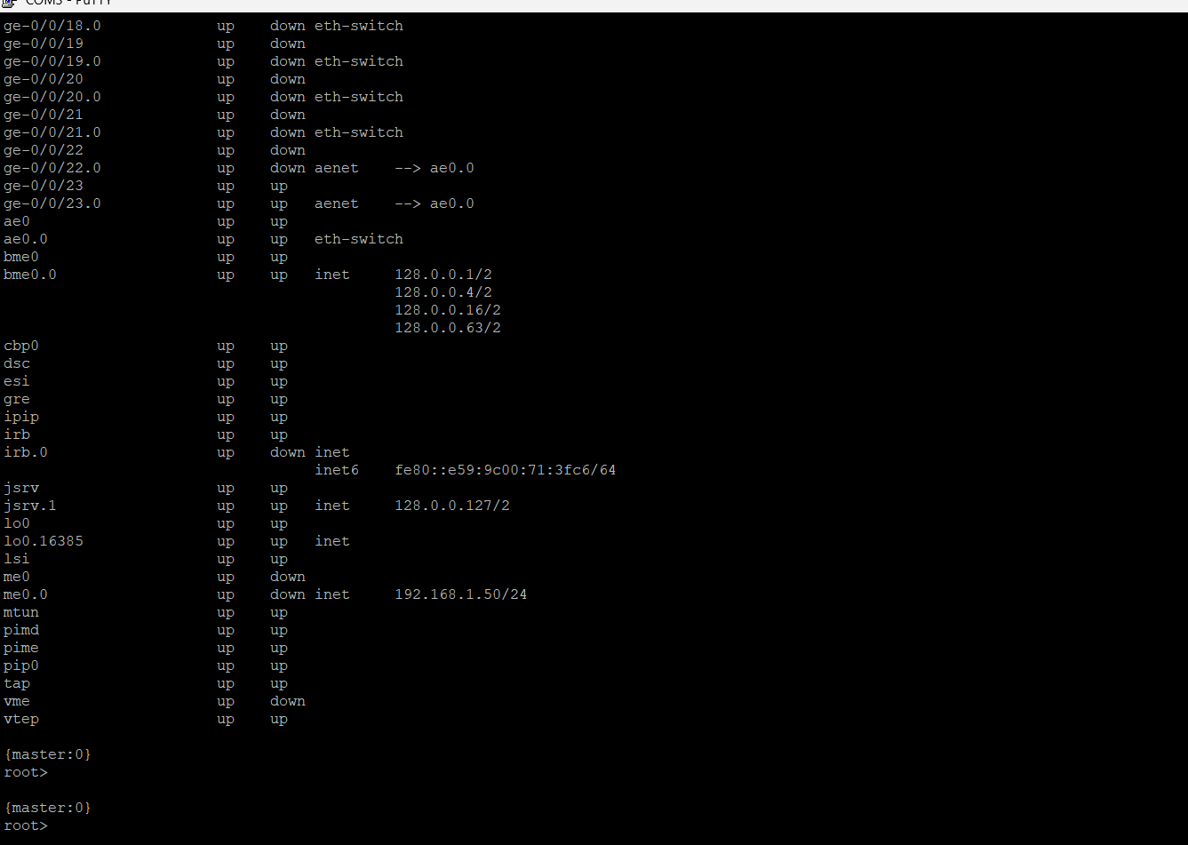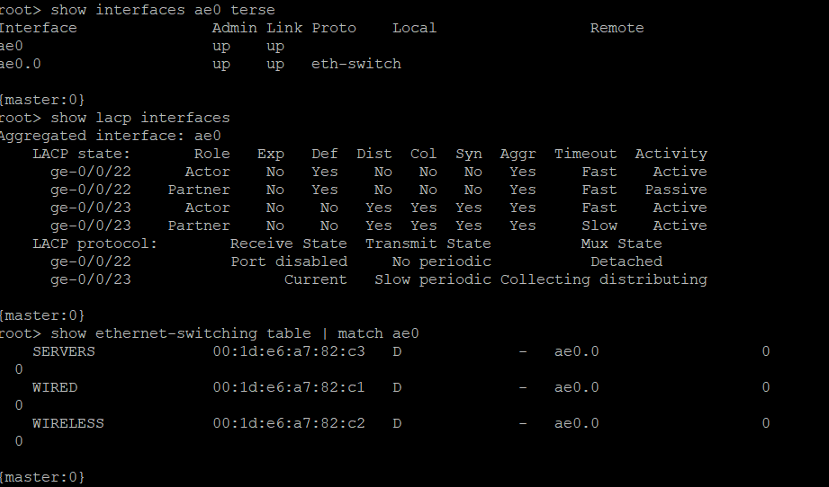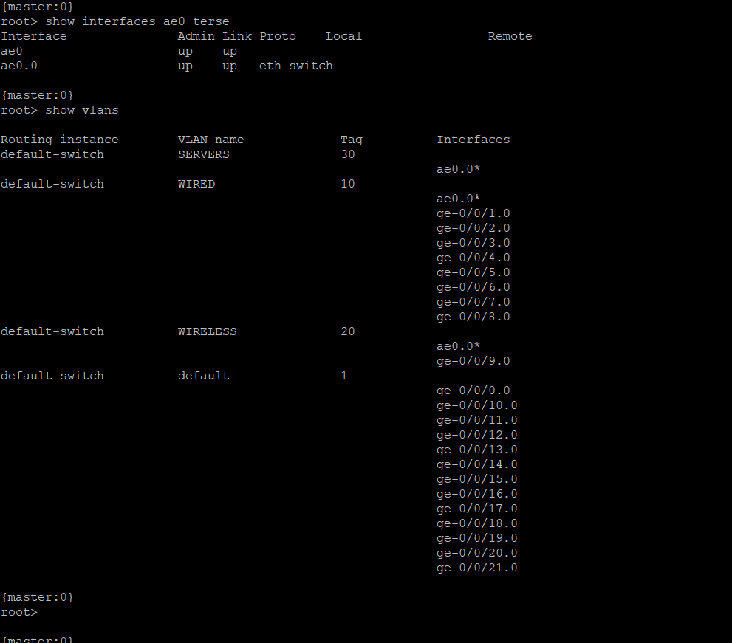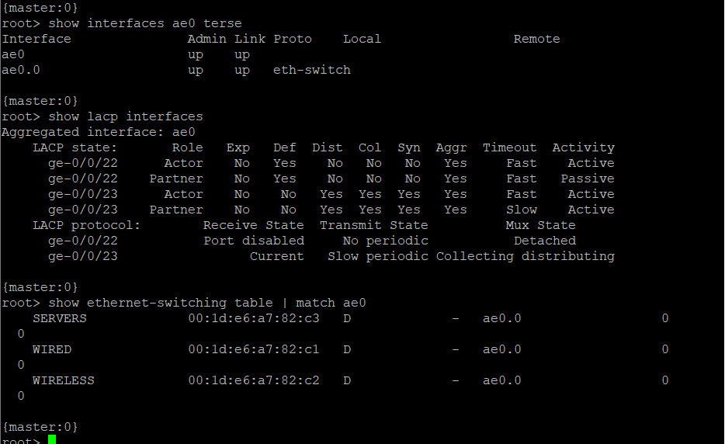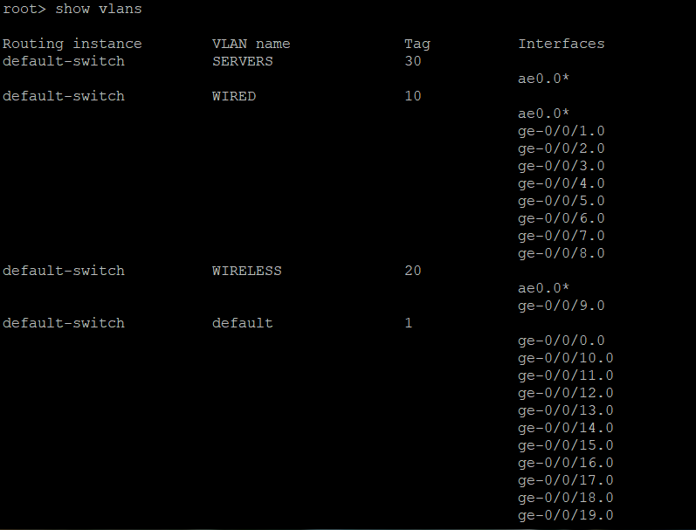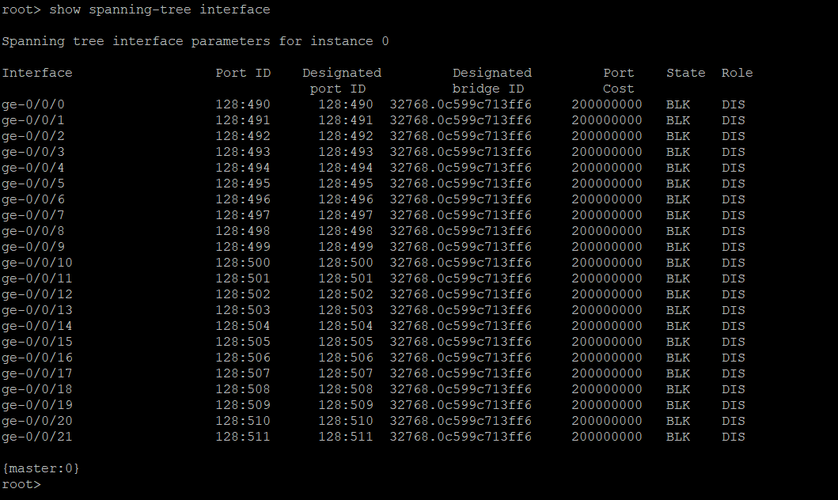

Server Switch Configuration (Cisco Catalyst 3560)

Step 1: Hostname Configuration: -
- enable
- configure terminal
- hostname SERVER-SW
Setting a unique hostname helps identify the device easily during troubleshooting.

Step 2: VLAN Creation: -
- vlan 10
- name WIRED_USERS
- exit
- vlan 20
- name WIRELESS_USERS
- exit
- vlan 30
- name SERVERS
- exit
VLANs are created to logically separate wired users, wireless users, and servers.

Step 3: Port Assignment: -
- interface range gi0/1 - 4
- switchport mode access
- switchport access vlan 30
- no shutdown
- interface range gi0/5 - 6
- switchport mode access
- switchport access vlan 10
- no shutdown
- interface range gi0/7 - 8
- switchport mode access
- switchport access vlan 20
- no shutdown
Ports are assigned based on device type:
- VLAN 30 → Servers
- VLAN 10 → Wired users
- VLAN 20 → Wireless users

Step 4: Trunk Configuration: -
- interface range gi0/5 – 6
- description LINK_TO_CORE
- switchport mode trunk
- switchport trunk allowed vlan 10,20,30
These ports now act as uplinks carrying all VLANs (10, 20, 30) between switches.

Step 5: EtherChannel Configuration: -
- interface range gi0/5 – 6
- channel-group 1 mode active
- interface port-channel 1
- switchport mode trunk
- switchport trunk allowed vlan 10,20,30
Gi0/5 and Gi0/6 are bundled into one logical link (Port-Channel1) for:
- Higher bandwidth
- Redundancy (if one link fails, the other stays active)

Step 6: Spanning Tree Protocol (STP): -
- spanning-tree mode rapid-pvst
RSTP prevents loops and ensures fast convergence in the network.

Step 7: Save Configuration: -
- write memory
Saves the configuration so it remains after reboot.

Step 8: Verification: -
- show vlan brief
- show etherchannel summary
- show spanning-tree
